Constructing Kite

Definition
# Source: AI Source: Provided by: [Data Path: Persons Table -> ID Column: 1, Name_En Column: Motasem Essam] -> From: [ChatGPT] on [7/25/2026]
Constructing a Kite is the geometric construction of a quadrilateral with two distinct pairs of adjacent equal sides, using classical geometric tools such as a straightedge and compass.
For kite $ABCD$:
$$\boxed{AB=AD}$$
and:
$$\boxed{BC=CD}$$
The equal sides are adjacent rather than opposite.
A kite is not necessarily a parallelogram, rectangle, rhombus, or square.

Fundamental Concept
# Source: AI Source: Provided by: [Data Path: Persons Table -> ID Column: 1, Name_En Column: Motasem Essam] -> From: [ChatGPT] on [7/25/2026]
A kite can be constructed from different types of given information, such as:
- two pairs of adjacent side lengths
- one diagonal and two side lengths
- three vertices
- a diagonal and symmetry information
- a pair of equal adjacent sides and an angle
The most fundamental construction uses two pairs of adjacent equal sides.
Suppose:
$$AB=AD=a$$
and:
$$BC=CD=b$$
The goal is to construct $ABCD$so that:
$$\boxed{AB=AD}$$
and:
$$\boxed{BC=CD}$$

Main Construction: Kite from Two Pairs of Adjacent Sides
# Source: AI Source: Provided by: [Data Path: Persons Table -> ID Column: 1, Name_En Column: Motasem Essam] -> From: [ChatGPT] on [7/25/2026]
Suppose the diagonal $AC$is constructed or given, and the required side lengths are:
$$AB=AD=a \\ BC=CD=b$$
Steps
- Construct the diagonal:
$$AC=d$$
- Set the compass to length $a$.
- With center $A$, draw arcs on one or both sides of $AC$.
- Set the compass to length $b$.
- With center $C$, draw arcs intersecting the arcs from $A$.
- Choose an intersection $B$for one side of the kite.
- If constructing a symmetric kite, use the corresponding intersection $D$on the opposite side of $AC$.
- Connect:
$$A-B-C-D-A$$
- The resulting quadrilateral is a kite.
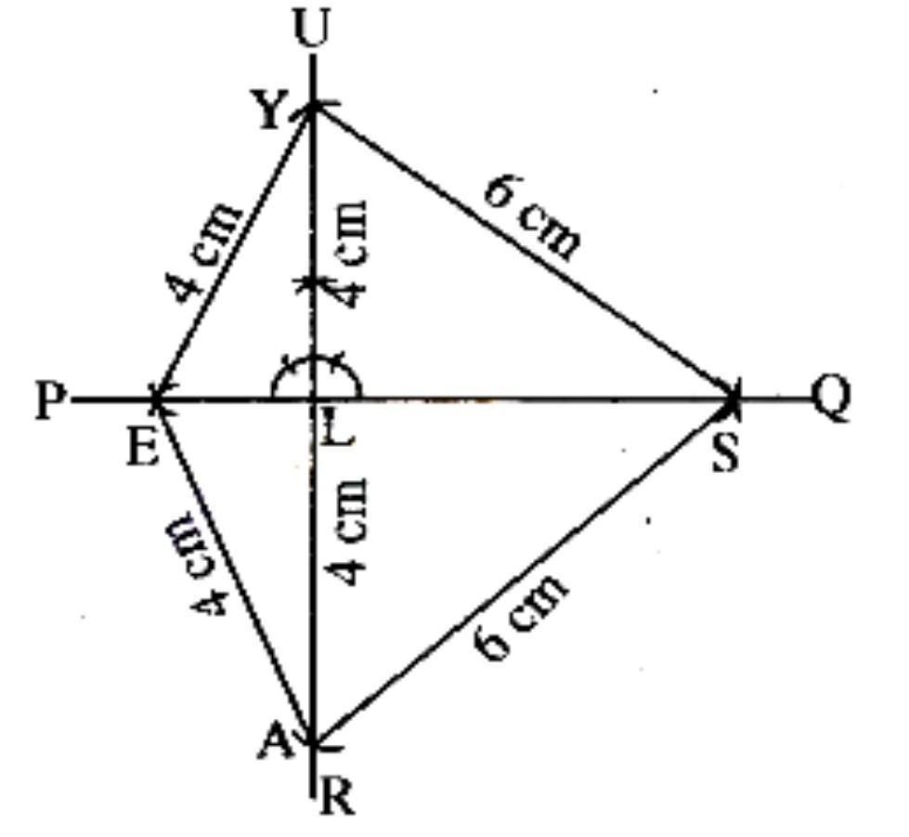
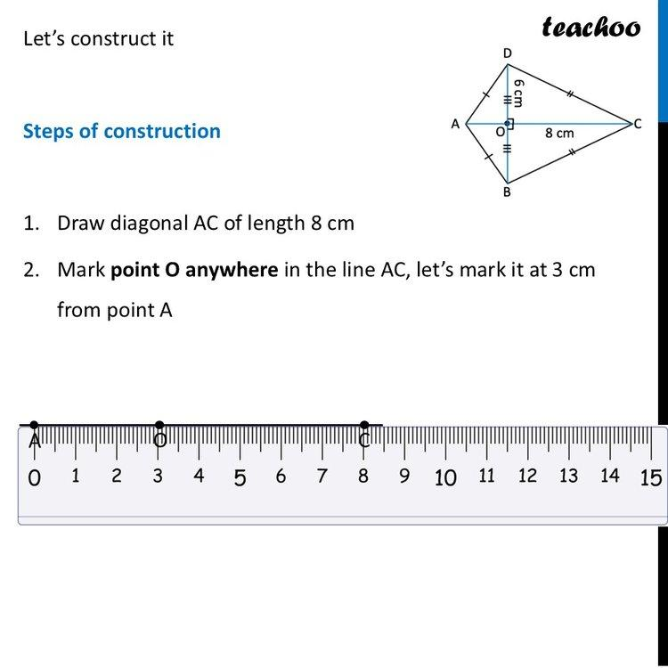
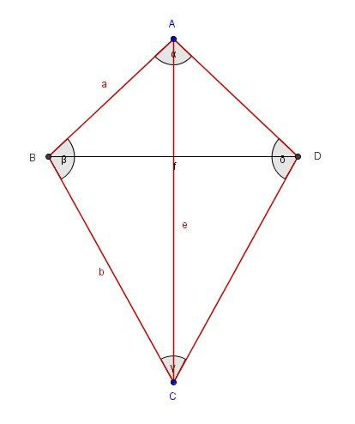
The construction guarantees:
$$\boxed{AB=AD=a}$$
and:
$$\boxed{BC=CD=b}$$
Therefore:
$$\boxed{ABCD\text{ is a kite}}$$

Why the Construction Works
# Source: AI Source: Provided by: [Data Path: Persons Table -> ID Column: 1, Name_En Column: Motasem Essam] -> From: [ChatGPT] on [7/25/2026]
Point $B$is located at the intersection of two circles:
- a circle centered at $A$with radius $a$
- a circle centered at $C$with radius $b$
Therefore:
$$AB=a$$
and:
$$BC=b$$
If $D$is the corresponding intersection on the other side of $AC$, then:
$$AD=a$$
and:
$$CD=b$$
Thus:
$$\boxed{AB=AD}$$
and:
$$\boxed{BC=CD}$$
which satisfies the defining side condition of a kite.

Constructing a Kite from Three Given Vertices
# Source: AI Source: Provided by: [Data Path: Persons Table -> ID Column: 1, Name_En Column: Motasem Essam] -> From: [ChatGPT] on [7/25/2026]
Suppose three vertices $A$, $B$, and $C$are given and the required kite has:
$$AB=AD$$
and:
$$BC=CD$$
Then $D$can be found as the point satisfying:
$$DA=AB$$
and:
$$DC=BC$$
Steps
- Set the compass to $AB$.
- With center $A$, draw an arc.
- Set the compass to $BC$.
- With center $C$, draw another arc.
- Their appropriate intersection gives $D$.
- Connect $D$to $A$and $C$.
Then:
$$\boxed{AB=AD}$$
and:
$$\boxed{BC=CD}$$
so $ABCD$is a kite.

Constructing a Symmetric Kite
# Source: AI Source: Provided by: [Data Path: Persons Table -> ID Column: 1, Name_En Column: Motasem Essam] -> From: [ChatGPT] on [7/25/2026]
A particularly important kite construction is a symmetric kite, where one diagonal acts as an axis of symmetry.
Suppose $AC$is the symmetry diagonal.
Then:
$$\boxed{AC⊥BD}$$
and $AC$bisects $BD$.
If $O$is the intersection of the diagonals:
$$\boxed{BO=OD}$$
The construction can therefore be based on constructing $B$and then reflecting it across $AC$to obtain $D$.
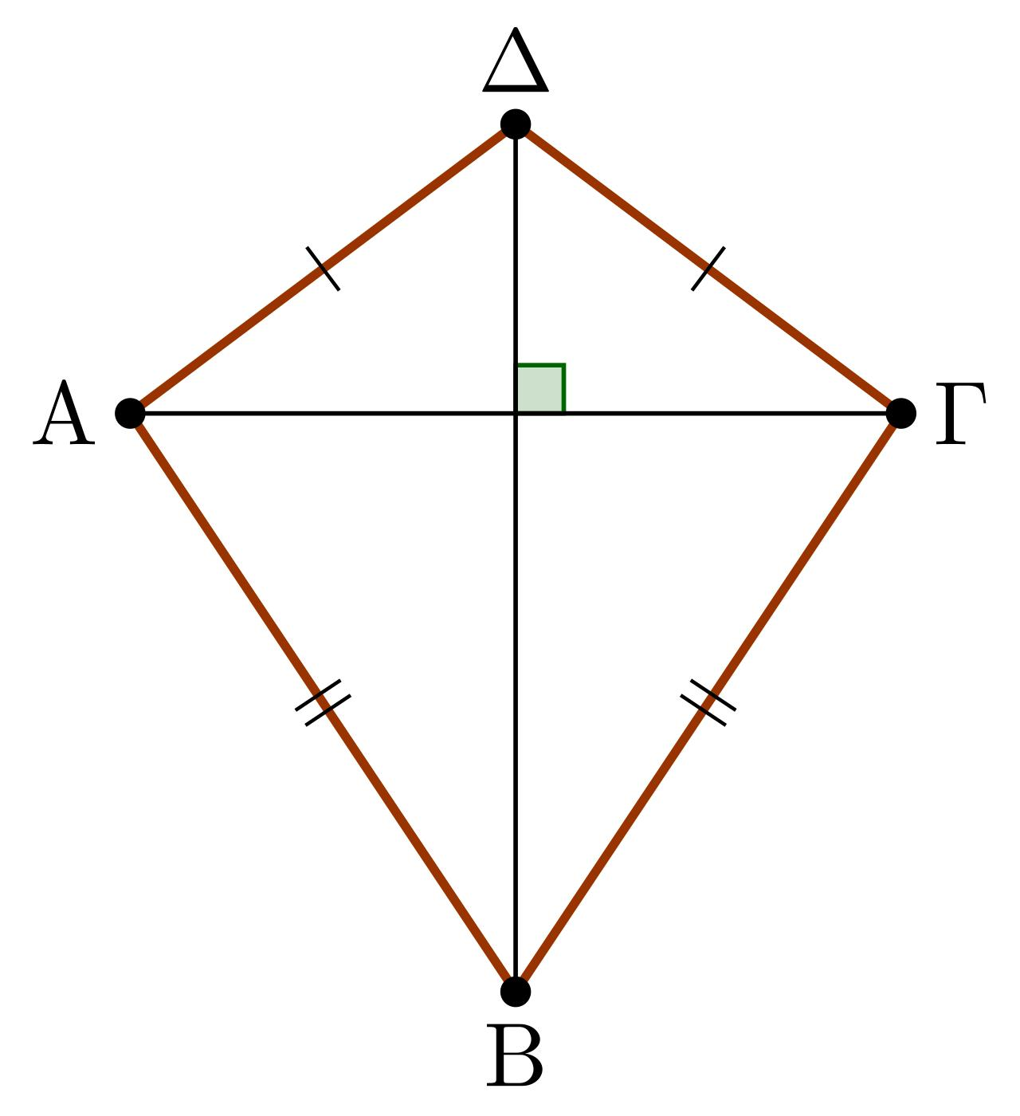
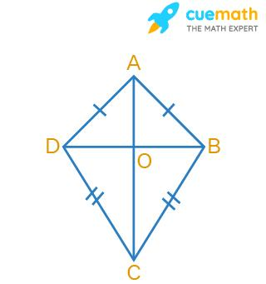
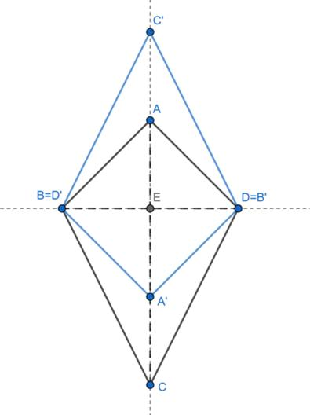

Properties of a Constructed Kite
# Source: AI Source: Provided by: [Data Path: Persons Table -> ID Column: 1, Name_En Column: Motasem Essam] -> From: [ChatGPT] on [7/25/2026]
For kite $ABCD$, where:
$$AB=AD$$
and:
$$BC=CD$$
Two Pairs of Adjacent Equal Sides
$$\boxed{AB=AD} \\ \boxed{BC=CD}$$
One Diagonal as an Axis of Symmetry
For a standard symmetric kite, diagonal $AC$is the symmetry axis.
Therefore:
$$\boxed{AC⊥BD}$$
and:
$$\boxed{BO=OD}$$
One Pair of Opposite Angles Is Equal
The angles between the unequal sides are equal:
$$\boxed{∠ABC=∠CDA}$$
under the standard labeling above.
Diagonal Bisecting an Angle
The symmetry diagonal $AC$bisects the angles at $A$and $C$:
$$\boxed{∠BAC=∠CAD}$$
and:
$$\boxed{∠BCA=∠ACD}$$
Area
If the diagonals have lengths $d_{1}$and $d_{2}$, then:
$$\boxed{A=\frac{d_{1}d_{2}}{2}}$$
For the standard symmetric kite, the diagonals are perpendicular, so this formula follows directly from the four right triangles formed by the diagonals.
Perimeter
If the two distinct side lengths are $a$and $b$:
$$\boxed{P=2\left(a+b\right)}$$

Constructing a Kite from Two Diagonals
# Source: AI Source: Provided by: [Data Path: Persons Table -> ID Column: 1, Name_En Column: Motasem Essam] -> From: [ChatGPT] on [7/25/2026]
If the two perpendicular diagonals are given, a kite can be constructed by placing their endpoints appropriately.
Suppose:
$$AC=d_{1}$$
and:
$$BD=d_{2}$$
Steps
- Construct diagonal $AC$.
- Construct its midpoint $O$, when the required kite has $AC$as the symmetry diagonal.
- Through $O$, construct a perpendicular to $AC$.
- Mark $B$and $D$on this perpendicular so that:
$$BO=OD$$
- Connect:
$$A-B-C-D-A$$
This creates a symmetric kite.
Important: two diagonal lengths alone do not always uniquely determine a kite. Additional information about the position of the diagonal intersection or the division of the diagonals may be required.

Types of Kite Construction
# Source: AI Source: Provided by: [Data Path: Persons Table -> ID Column: 1, Name_En Column: Motasem Essam] -> From: [ChatGPT] on [7/25/2026]
These are primarily construction situations, rather than different mathematical types of kites.
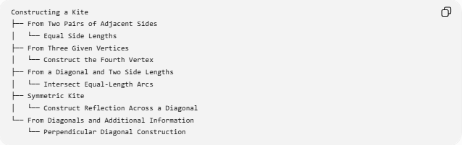
Constructing a Kite
├── From Two Pairs of Adjacent Sides
│ └── Equal Side Lengths
├── From Three Given Vertices
│ └── Construct the Fourth Vertex
├── From a Diagonal and Two Side Lengths
│ └── Intersect Equal-Length Arcs
├── Symmetric Kite
│ └── Construct Reflection Across a Diagonal
└── From Diagonals and Additional Information
└── Perpendicular Diagonal Construction

Construction Classification
# Source: AI Source: Provided by: [Data Path: Persons Table -> ID Column: 1, Name_En Column: Motasem Essam] -> From: [ChatGPT] on [7/25/2026]
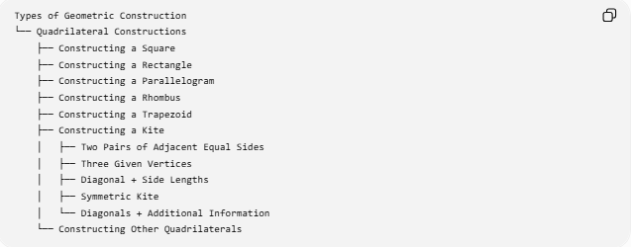
Types of Geometric Construction
└── Quadrilateral Constructions
├── Constructing a Square
├── Constructing a Rectangle
├── Constructing a Parallelogram
├── Constructing a Rhombus
├── Constructing a Trapezoid
├── Constructing a Kite
│ ├── Two Pairs of Adjacent Equal Sides
│ ├── Three Given Vertices
│ ├── Diagonal + Side Lengths
│ ├── Symmetric Kite
│ └── Diagonals + Additional Information
└── Constructing Other Quadrilaterals
A more detailed structure is:
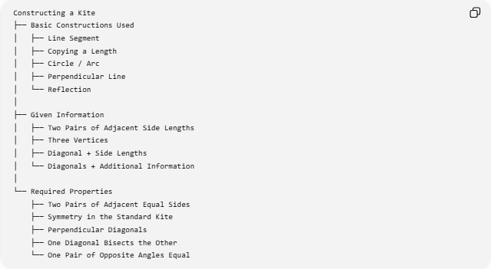
Constructing a Kite
├── Basic Constructions Used
│ ├── Line Segment
│ ├── Copying a Length
│ ├── Circle / Arc
│ ├── Perpendicular Line
│ └── Reflection
│
├── Given Information
│ ├── Two Pairs of Adjacent Side Lengths
│ ├── Three Vertices
│ ├── Diagonal + Side Lengths
│ └── Diagonals + Additional Information
│
└── Required Properties
├── Two Pairs of Adjacent Equal Sides
├── Symmetry in the Standard Kite
├── Perpendicular Diagonals
├── One Diagonal Bisects the Other
└── One Pair of Opposite Angles Equal
The last group describes properties of the standard/symmetric kite. Not every quadrilateral satisfying a broad “two pairs of adjacent equal sides” definition should automatically be assigned every symmetry property without checking the specific configuration.

Kite and Other Quadrilateral Constructions
# Source: AI Source: Provided by: [Data Path: Persons Table -> ID Column: 1, Name_En Column: Motasem Essam] -> From: [ChatGPT] on [7/25/2026]
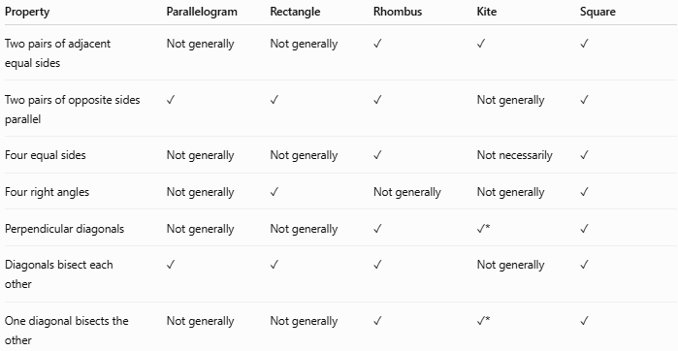
Property | Parallelogram | Rectangle | Rhombus | Kite | Square
Two pairs of adjacent equal sides | Not generally | Not generally | ✓ | ✓ | ✓
Two pairs of opposite sides parallel | ✓ | ✓ | ✓ | Not generally | ✓
Four equal sides | Not generally | Not generally | ✓ | Not necessarily | ✓
Four right angles | Not generally | ✓ | Not generally | Not generally | ✓
Perpendicular diagonals | Not generally | Not generally | ✓ | ✓* | ✓
Diagonals bisect each other | ✓ | ✓ | ✓ | Not generally | ✓
One diagonal bisects the other | Not generally | Not generally | ✓ | ✓* | ✓
$*$For the standard/symmetric kite.

Kite and Rhombus
# Source: AI Source: Provided by: [Data Path: Persons Table -> ID Column: 1, Name_En Column: Motasem Essam] -> From: [ChatGPT] on [7/25/2026]
A rhombus satisfies:
$$AB=BC=CD=DA$$
A kite requires:
$$AB=AD$$
and:
$$BC=CD$$
Therefore, a rhombus also satisfies the usual kite side condition, if the definition of kite allows the four-equal-side special case.
Some textbooks, however, define a kite as having two distinct pairs of adjacent equal sides, which excludes a rhombus.
So the terminology depends on the adopted definition.

Example
# Source: AI Source: Provided by: [Data Path: Persons Table -> ID Column: 1, Name_En Column: Motasem Essam] -> From: [ChatGPT] on [7/25/2026]
Construct a kite with:
$$AB=AD=5\text{ cm}$$
and:
$$BC=CD=3\text{ cm}$$
Construction
- Construct diagonal $AC$with an appropriate length.
- With center $A$and radius $5$cm, draw an arc.
- With center $C$and radius $3$cm, draw an arc.
- Their intersection on one side of $AC$gives $B$.
- Construct the corresponding intersection on the other side of $AC$to obtain $D$.
- Connect:
$$A-B-C-D-A$$
Therefore:
$$\boxed{AB=AD=5\text{ cm}}$$
and:
$$\boxed{BC=CD=3\text{ cm}}$$
The perimeter is:
$$P=2\left(5+3\right) \\ \boxed{P=16\text{ cm}}$$

Tools Used
# Source: AI Source: Provided by: [Data Path: Persons Table -> ID Column: 1, Name_En Column: Motasem Essam] -> From: [ChatGPT] on [7/25/2026]
Straightedge
Used to:
- draw the sides
- connect vertices
- construct diagonals
- construct perpendicular or symmetry lines
Compass
Used to:
- transfer side lengths
- draw arcs
- locate vertices
- construct equal distances
Therefore:
$$\boxed{\text{Classical Kite Construction}=\text{Straightedge + Compass}}$$

Key Points
# Source: AI Source: Provided by: [Data Path: Persons Table -> ID Column: 1, Name_En Column: Motasem Essam] -> From: [ChatGPT] on [7/25/2026]
- A kite is a quadrilateral with two pairs of adjacent equal sides.
- The equal sides are adjacent, not opposite.
- A standard symmetric kite has a diagonal that acts as an axis of symmetry.
- In that standard configuration:
$$AC⊥BD$$
- The symmetry diagonal bisects the other diagonal.
- One pair of opposite angles is equal.
- The symmetry diagonal bisects two opposite vertex angles.
- The area is:
$$A=\frac{d_{1}d_{2}}{2}$$
for the standard kite with perpendicular diagonals.
- The perimeter is:
$$P=2\left(a+b\right)$$
- A rhombus may be considered a special kite under definitions that allow all four sides to be equal.
- Two diagonal lengths alone do not necessarily determine a unique kite.

Conclusion
# Source: AI Source: Provided by: [Data Path: Persons Table -> ID Column: 1, Name_En Column: Motasem Essam] -> From: [ChatGPT] on [7/25/2026]
Constructing a Kite is the geometric construction of a quadrilateral with two pairs of adjacent equal sides. The fundamental construction uses compass arcs to transfer equal lengths and locate the vertices. A common symmetric construction uses a diagonal as an axis of symmetry, producing perpendicular diagonals and one diagonal that bisects the other. Kite construction therefore combines line-segment construction, copying lengths, arcs, perpendicular construction, and symmetry/reflection.

